|  |
| --- |
| Assessement  **%** |

**Name**: Samuel Černý **Class: 2. A**

**Topic: Canada**

**Three interesting introductory sentences to the topic:**

1. Canada is called ‚The Country of Lakes‘.

2. Canadian national animal is the one and only beaver.

3. In Canada there is a very bad density of roads.

**Words associated and connected to the topic given:**

|  |  |  |  |  |
| --- | --- | --- | --- | --- |
| Maple syrup | french | english | lacrosse | Ice hockey |
| poutine | tourtiére | Mount Logan | beaver | Ontario |
| Justin Bieber | Ryan Reynolds | Niagara falls | lakes | Polar bear |
| Nickelback | Rush | curling | Senate of appounded | monarch |

**Create a sentence:**

**- in Present simple tense:**

National sports of Canada are lacrosse and ice hockey.

**- in Present perfect:**

Canada has always been the 2. largest country in the world.

-**in Past Simple:**

Maple syrup was discovered in 1557.

**Conditional clause:**

If I ever visit Canada, I will definitely visit Niagara falls.

**Make up 3 interesting complex sentences (souvětí):**

1. Many famous people come from Canada, people like Ryan Reynolds or Justin Bieber, there are also some worldwide known bands there, for example Nickelback or Rush come from this cold country.

2. Everybody knows that Canada’s national sports are lacrosse and ice hockey, but noone talks about canadian football, or their basketball teams, although you can hear people talk about canadian curling.

3. Canadian couisine really is amusing, dishes like tourtiére or poutine are great examples of what you can eat there, but we definitely cant forget their amazing maple syrup.

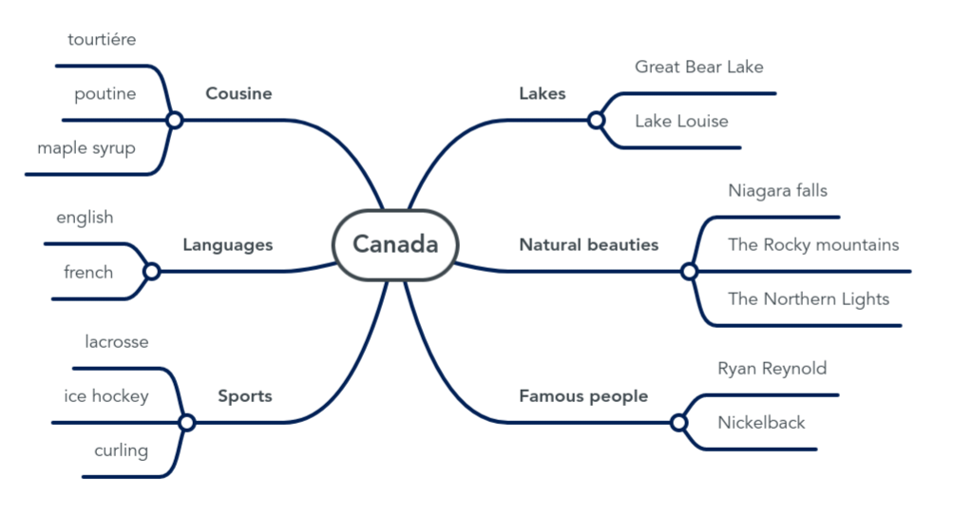**Mind map – Outline more or less detailed mind map (according to your learning abilities and preferences, or use bulleted point to work out a summary of the topic):**